Agile Scrum and Version Control System-Practice Project

1.9) Create and deploy files to GitHub via Git

Aim:

To retrieve student data from text file and to display it.

GitHub link:

<https://github.com/Sukirthalakshmanan1/Studentdata>

Procedure:

Step 1:Write the content(student data )in text file.

Step 2: Create a Visual studio Windows console project.Write the code in Program.cs

Step 3:Inherit the text file in our code.

File.ReadAllLines(“path”) method which opens a text file,read all lines of the file and closes the file.This method is used to retrieve the student data from text file and to display it.

Step 4:create a repository in Github via visual studio

Step 5:Commit all the changes and Push the code to Github.

Code Screenshots:

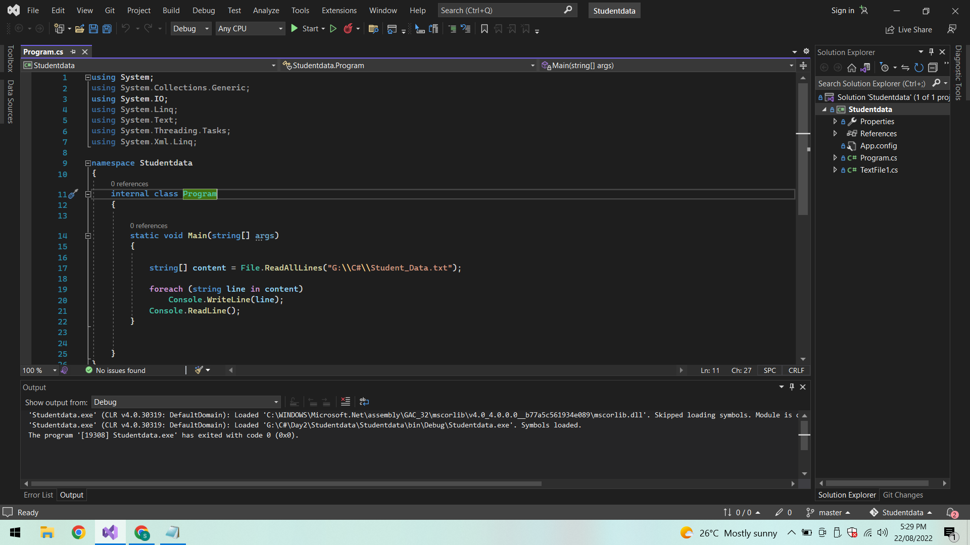

Output:

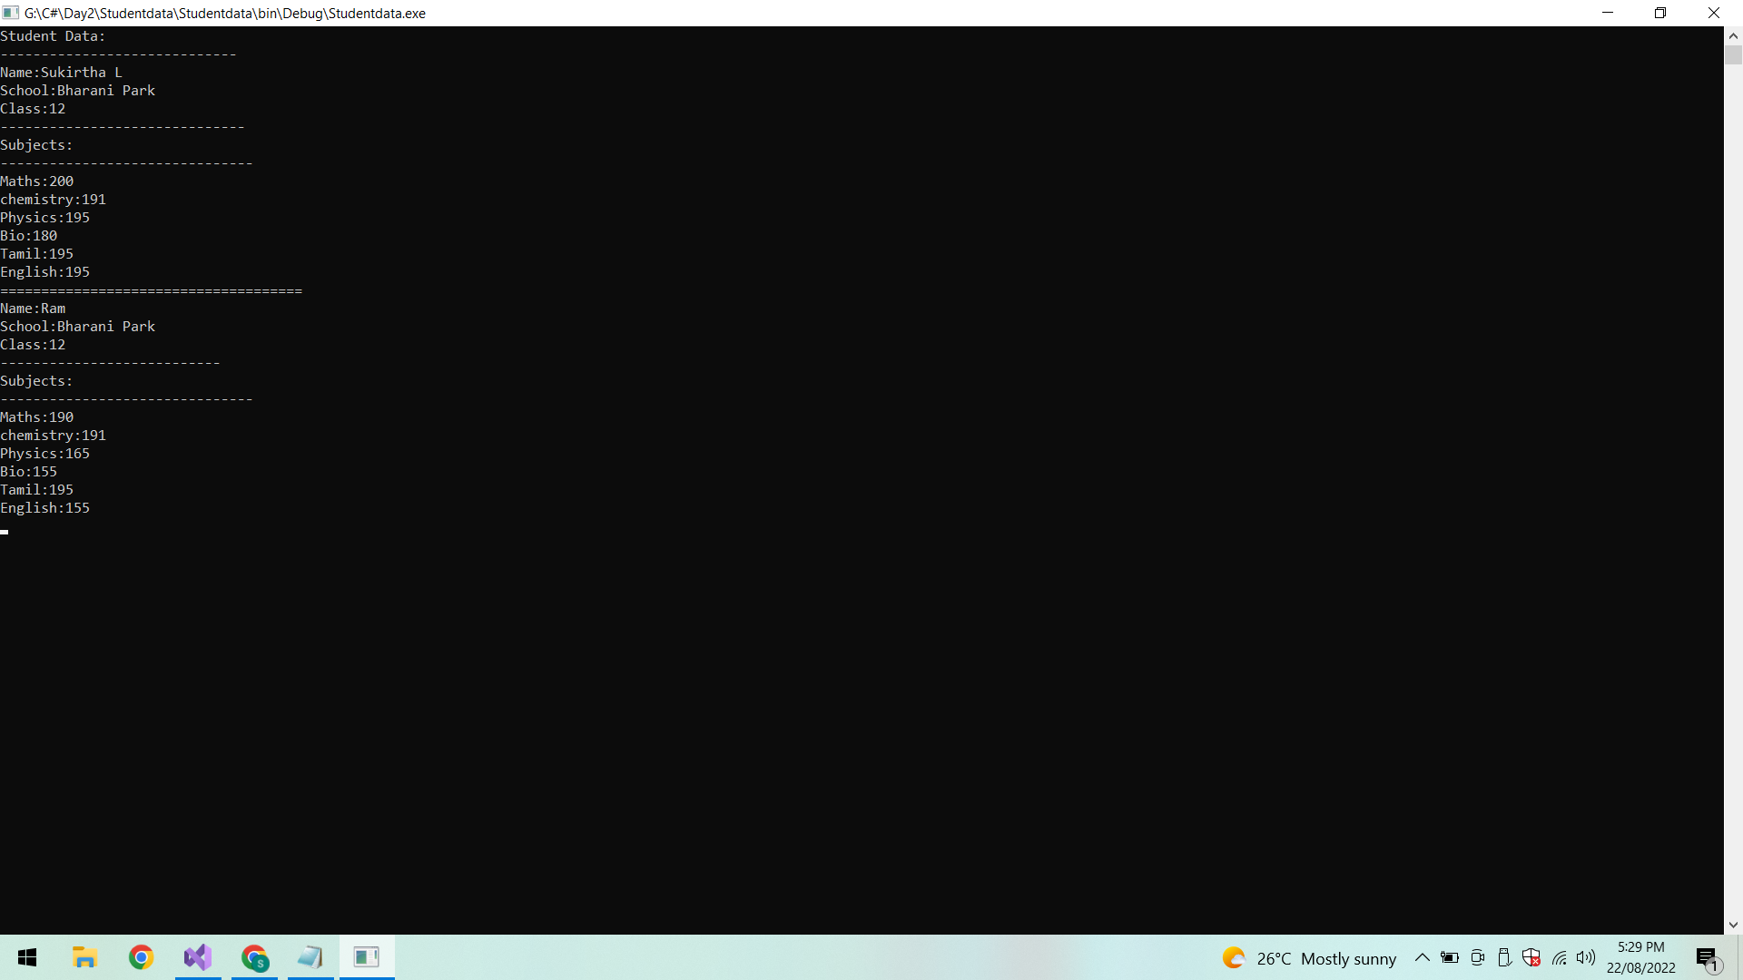

Conclusion:

Thus the student data is retrieved from text file and displayed.